Tbilisi – Ananuri – Gudauri – Kazbegi

Duration of the program – 4 days / 3 nights
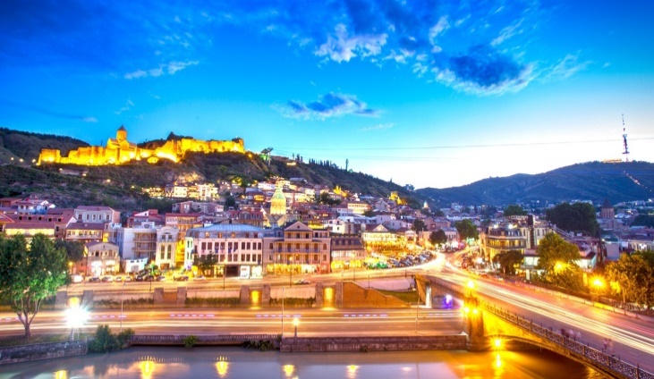
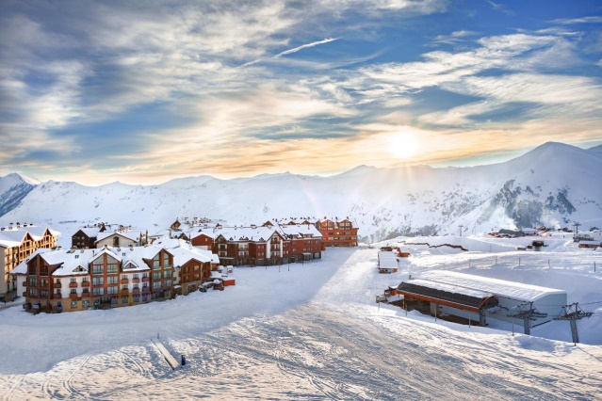
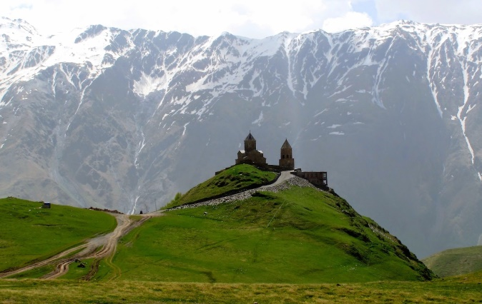

Day 1: Arrival to Tbilisi
- Arrival to Tbilisi
- Warm welcome at the airport, transfer to the hotel
- Overnight in Tbilisi
Day 2: Tbilisi City Tour with Mtatsminda
- Breakfast in the hotel
- 10:00 starting the tour
- It is time to explore Tbilisi city tour, visiting main attractions of the city:
- Holy Trinity Church – the main cathedral of the Georgian Orthodox Church located in Tbilisi. Constructed between 1995 and 2004, it is the third-tallest Eastern Orthodox cathedral in the world and one of the largest religious buildings in the world by total area. Sameba is a synthesis of traditional styles dominating the Georgian church architecture at various stages in history and has some Byzantine undertones.
- Metekhi plateau with the view on Old Town. Virgin Mary Metekhi church is located on the left bank of the river Mtkvari, on the cliff plateau, the first church on this place was probably built by Vakhtang Gorgasali symbolically resembling the church built on virgin Mary’s tomb in Gethsemane garden in Jerusalem.
- Rike park and Bridge of Peace (The glass bridge). It is a pedestrian glass and steel bridge in a bow-shaped design that sits over the Mtkvari (Kura) river in Georgian capital. It was officially opened in May 2010. The bridge was brought to Georgia from Italy in 200 unassembled components. The bridge is 156 meters long and has more than 10 000 LED bulbs built-in, that are switched on daily 90 minutes before the sunset.
- Narikala Fortress – the main landmark of Tbilisi, ancient fort defending city and opening breathtaking views of the capital. Also called the Mother Fortress of Tbilisi, Narikala is an ancient symbol of Tbilisi’s defence. The fortress was established in the 4th century, around the period when the city itself was founded.
- Abanotubani (baths district) – the oldest district of the capital where it’s history starts from. Located at the eastern bank of the Mtkvari River at the foot of Narikala fort across Metekhisubani.
- Leghvtakhevi waterfall – beautiful nature wonder in the heart of old city.
- Mtatsminda Park – the holy mountain with amusement park opening beautiful view of Tbilisi. The park has carousels, water slides, a roller-coaster, funicular, and a big Ferris Wheel at the edge of the mountain, offering a splendid view over the city.
- Tour will be finished around 16:00
- Overnight in Tbilisi
Day 3: Tbilisi – Ananuri – Gudauri – Kazbegi – Tbilisi
- Breakfast in the hotel
- 10:00 starting the tour
- Trip on Georgian Military road to Kazbegi.
- During this trip you will enjoy beautiful mountain views and fresh air.
- First stop at Zhinvali reservoir – hydroelectric dam on the Aragvi River with amazing views near Ananuri fortress – architectural complex of the late feudal times in Georgia. Built on the right bank of Aragvi River in 16th–17th cc, it was the main seat of Aragvi Eristavi – Dukes dynasty since 13th century.
- Second stop near the monument of friendship built in 1983 after signing the treaty of Georgievsk.
- in Gudauri, opening beautiful views from the mountains.
- Passing by Gudauri ski resort – 2196 meters above the sea.
- Visiting Gergeti Trinity Church in Kazbegi by Jeeps in Stepantsminda. The elevation is 2170 meters. The Gergeti Trinity Church was built in the 14th century, and is the only cross-cupola church in Khevi province.
- Tour will be finished around 19:00
- Overnight in Tbilisi

Day 4: Departure from Tbilisi
- Breakfast in the hotel
- Check out from hotel at 12 noon
- Free time before departure
- Transfer to the airport and farewell to Georgia

Inclusions
- 3 nights’ accommodation in the hotel including breakfast
- Private Airport chauffeurs
- Private transportation through the tour route in the comfortable car/minivan
- Private sightseeing tours with English speaking driver-guide
- Private jeep in Kazbegi
- Tbilisi cable car tickets

Optional
- Lunches / Dinners
- Early check in to the hotel
- Late check out from the hotel
- Travel insurance
- Entry tickets

Exclusions
- Flight tickets
- Tips
- Visa charges (if required)

Price valid from 01 March till 17 March 2020
Price per person based on chosen accommodation.

Iveria Inn 4* (10 min to city center)  Child policy:  Kids below 5,99 – FOC  Kids from 6 to 11,99 – 70 USD with extra bed  Kids from 12 y.o – considered as adult | Single room: 270 USD
 | Double room: 141 USD
 | Triple room: 116 USD
 | Family room (2 connecting rooms): 99 USD
Metekhi Line 4* (city center)  Child policy:  Kids below 5,99 – FOC  Kids from 6 to 11,99 – 50 USD with extra bed  Kids from 12 y.o – considered as adult | Single room: 303 USD
 | Double room: 160 USD
 | Triple room: 117 USD
 | Family room: 104 USD
Park Hotel 4* (city center)  Child policy:  Kids below 5,99 – FOC  Kids from 6 to 11,99 – 85 USD with extra bed  Kids from 12 y.o – considered as adult | Single room: 303 USD
 | Double room: 160 USD
 | Triple room: 134 USD
 | Family room (2 connecting room): 104 USD

Price valid from 01 March till 30 April
Price per person based on chosen accommodation.

Iveria Inn 4* (10 min to city center) – from 18 March 2020  Child policy:  Kids below 5,99 – FOC  Kids from 6 to 11,99 – 70 USD with extra bed  Kids from 12 y.o – considered as adult | Single room: 336 USD
 | Double room: 176 USD
 | Triple room: 134 USD
 | Family room (2 connecting rooms):133 USD
Metekhi Line 4* (city center) – from 18 March 2020  Child policy:  Kids below 5,99 – FOC  Kids from 6 to 11,99 – 50 USD with extra bed  Kids from 12 y.o – considered as adult | Single room: 336 USD
 | Double room: 184 USD
 | Triple room: 134 USD
 | Family room: 104 USD
Brim Tbilisi 4* (city center)  Child policy:  Kids below 5,99 – FOC  Kids from 6 to 11,99 – 60 USD with extra bed  Kids from 12 y.o – considered as adult | Single room: 353 USD
 | Double room: 184 USD
 | Triple room: 145 USD
 | Family room: 121 USD
Sole Palace 4* (city center)  Child policy:  Kids below 5,99 – FOC  Kids from 6 to 11,99 – 70 USD with extra bed  Kids from 12 y.o – considered as adult | Single room: 353 USD
 | Double room: 184 USD
 | Triple room: 139 USD
 | Family room (2 connecting rooms): 141 USD
IOTA Tbilisi 5* (city center)  Child policy:  Kids below 5,99 – FOC  Kids from 6 to 11,99 – 70 USD with extra bed  Kids from 12 y.o – considered as adult | Single room: 534 USD
 | Double room: 308 USD
 | Triple room: 238 USD
 | Family room: N/A
*Please note hotels remain subject to availability at the time of booking

